Aim: To optimize the performance of a classification model by tuning its hyperparameters using SageMaker
Theory:
- Amazon SageMaker:
A fully managed machine learning service that simplifies model training, tuning, and deployment. It enables data scientists to run large-scale experiments efficiently in the cloud.
- Hyperparameter Tuning (HPO):
The process of automatically searching for the best combination of hyperparameters that optimize a model’s performance metric (e.g., accuracy or AUC).
- XGBoost Algorithm:
A gradient boosting framework that is efficient and widely used for classification and regression tasks. It has several tunable hyperparameters such as learning rate (eta), tree depth (max_depth), and sampling rate (subsample).
- Objective Metric:
The metric used to evaluate performance during tuning. For binary classification, AUC (Area Under Curve) is a common choice.
- Amazon S3:
Serves as the storage location for datasets and model outputs used during SageMaker training and tuning jobs.

Procedure:
Step 1: Launch a SageMaker Notebook Instance
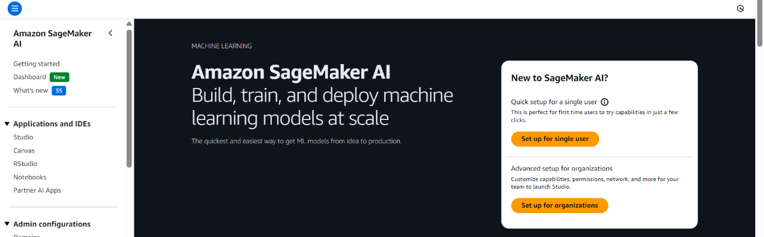
- Open the AWS Management Console and navigate to Amazon SageMaker.
- Create a new Notebook Instance (e.g., data-preprocessing-lab).
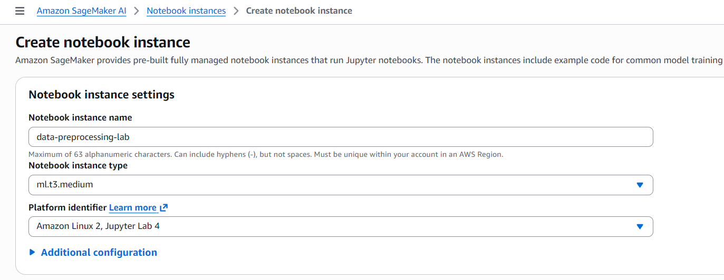
- Choose instance type ml.t3.micro (cost-efficient for small datasets).
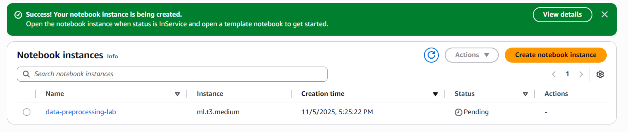
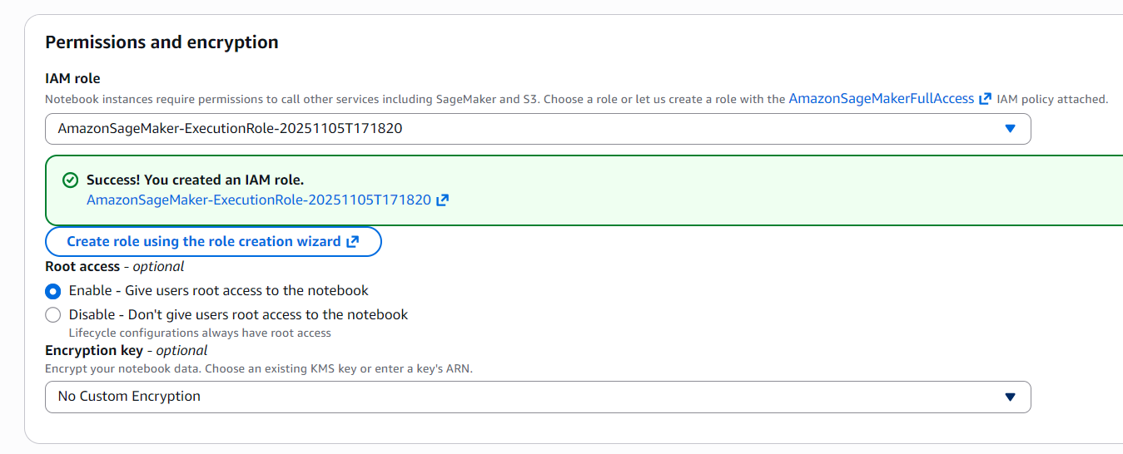
- Create an IAM role with S3 full access and attach it.

- Once the status is InService, click Open Jupyter to begin.

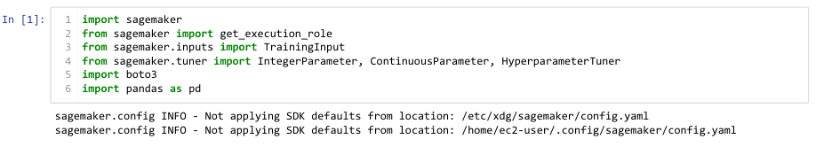
Step 2: Import Required Libraries

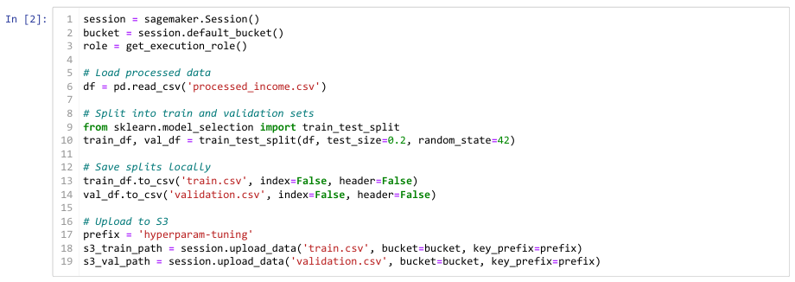
Step 3: Load and Prepare the Dataset

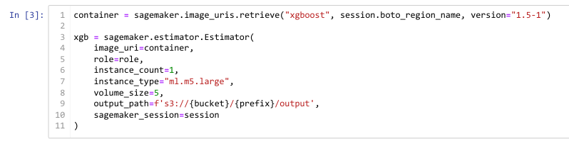
Step 4: Create and Configure the Estimator

Step 5: Define the Hyperparameter Ranges
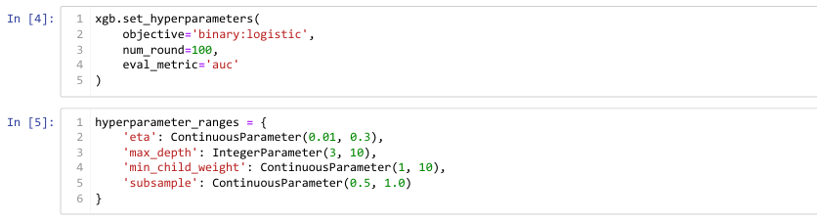

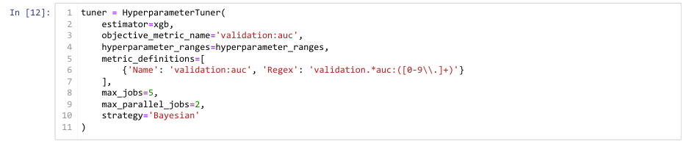
Step 6: Create the Hyperparameter Tuner

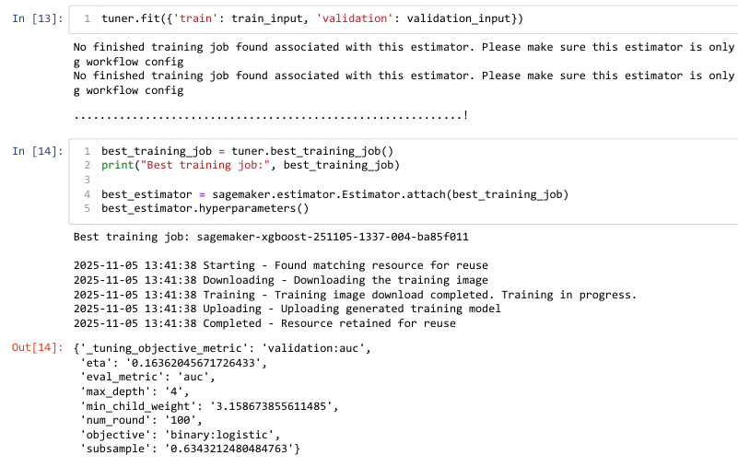
Step 7: Perform Feature Engineering and Retrieve the Best Model

Conclusion:
In this lab, we used Amazon SageMaker’s Hyperparameter Tuning capability to optimize an XGBoost classification model for predicting income levels.
We configured tuning ranges for key hyperparameters, executed multiple training jobs automatically, and identified the best-performing model using the AUC metric.
This demonstrated the power of SageMaker’s automated model tuning to enhance performance with minimal manual effort.
The deployment step is optional and can be performed later to host the model for live inference once optimal hyperparameters have been established.

